SQL Queries:

1. Titles from the table

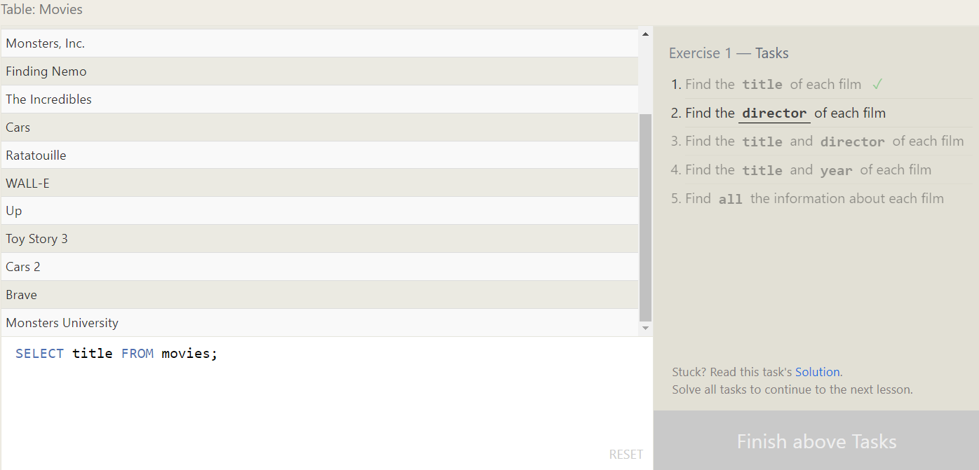

1. Directors from the table

1. Title and Director of each film

4.Title and Year of each film

5.All information about each film

